CSD211 Lab4b

1. Preface
2. Objectives
3. Deliverables
4. Assignment

# Preface

* **Place a header at the beginning of each program that looks like this**

**/\*\***

**Author : Your Name**

**Date : the date**

**Description : describe what your program does.**

**\*\*/**

* **place your programs in packages.   
  put lab1 question 1 in package  
   lab2.q1  
  put lab1 question 2 in package  
   lab2.q2  
  etc…  
  If your program is in a class called Main.java then your packages should look like this…  
  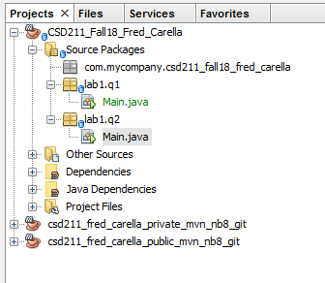**
* **commit and then push the programs to your git repo.**
* **place comments indicating the INPUT, PROCESS and OUTPUT sections of your program.**

# Objectives

* perform all the procedures outlined in the Assignment below

# Deliverables

* Complete the programming questions outlined below.  
  Then….
* in Netbeans, commit your files to your local repository.   
  **Do this every time you modify code.**
* in Netbeans, push all your code to your remote git repository (git/push).   
  **Do this frequently, after every coding session.**
* Answer any questions you are asked in a file called **Answers.docx**then upload Answers.docx to your dropbox.  
  **Do this when you complete answering the questions.**
* Upload a file called README to your LMS dropbox with the following information in it (a plain text file will work).   
    
  Name: your name  
  Date: the date  
  Repo: <https://gitlab.com>/<the url of your project. You get this from gitlab.com>|  
    
  **Do this when you’re done and the lab is ready for marking.**
* When you upload the README file to LMS dropbox, consider your lab handed in. Your teacher will be notified that the lab is submitted and that its ready for marking. Teacher marks it, and the mark automagically appears in your LMS Marks.  
    
  **Do not email me a message or a zip file of the project, after all we are in the 21’st century now :)**

# Assignment

1. Write a unit test to test the adding, editing and deleting of cars in lab 4.